Schema - <https://youtu.be/pSRw7FzJN4s> (1:23 min)

Project Running - <https://youtu.be/w_5smSKmYVs> (1:26 min)

My project is implemented using Python, output can be seen on command prompt.

Tables/Views –

1. Students – Stores the Students’ information
2. Faculty – Stores the Faculty’s information
3. Admin – Stores the owner’s information
4. Track_stu_rent – tracks the number of books rented by a particular student
5. Track_fac_rent – tracks the number of books rented by a particular faculty
6. V1 – has joined information of books and authors.
7. Books – Has book related information.
8. Authors – Has author related information, for each book present in the Books table.

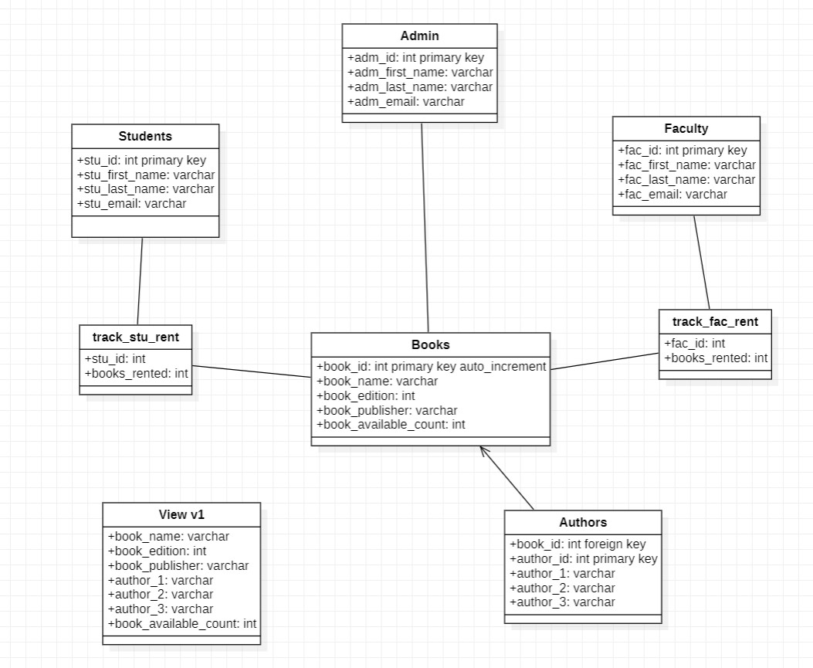

Delivered –

* I have 51 distinct books available in my database, but in reality, it stores 625 books (book_available_count column has the number of books present of each type).
* User can sign in/up.
* Unsigned in user (student or faculty) can display the books available (using view), get a count of number of books and get a count of distinct books.
* Signed in user (student or faculty) can rent book, check dues and checked the number of books rented.

Key SQL Commands used –

CREATE TABLE `lms`.`books` (

`book_id` INT NOT NULL AUTO_INCREMENT,

`book_name` VARCHAR(45) NOT NULL,

`book_edition` INT NOT NULL,

`book_publisher` VARCHAR(45) NULL,

`book_available_count` INT NULL,

PRIMARY KEY (`book_id`));

CREATE TABLE `lms`.`author` (

`book_id` INT NULL,

`author_id` INT NOT NULL,

`author_1` VARCHAR(45) NULL,

`author_2` VARCHAR(45) NULL,

`author_3` VARCHAR(45) NULL,

PRIMARY KEY (`author_id`),

INDEX `book_id_idx` (`book_id` ASC) VISIBLE,

CONSTRAINT `book_id`

FOREIGN KEY (`book_id`)

REFERENCES `library`.`books` (`book_id`)

ON DELETE CASCADE

ON UPDATE CASCADE);

CREATE TABLE `lms`.`students` (

`stu_id` INT NOT NULL,

`stu_first_name` VARCHAR(45) NOT NULL,

`stu_last_name` VARCHAR(45) NOT NULL,

`stu_email` VARCHAR(45) NOT NULL,

PRIMARY KEY (`stu_id`));

CREATE TABLE `lms`.`faculty` (

`fac_id` INT NOT NULL,

`fac_first_name` VARCHAR(45) NOT NULL,

`fac_last_name` VARCHAR(45) NOT NULL,

`fac_email` VARCHAR(45) NOT NULL,

PRIMARY KEY (`fac_id`));

CREATE TABLE `lms`.`track_stu_rent` (

`stu_id` INT NULL,

`books_rented` INT NULL);

CREATE TABLE `lms`.`track_fac_rent` (

`fac_id` INT NULL,

`book_rented` INT NULL);

#create view to display the details of books

CREATE VIEW v1 AS SELECT book_name, book_edition, book_publisher, author_1, author_2, author_3, book_available_count FROM books NATURAL JOIN author;

INSERT INTO library.books (book_name, book_edition, book_publisher, book_available_count) VALUES ('Database System Concepts', 4, 'McGrawHill', 20);

INSERT INTO lms.author (book_id, author_1, author_2, author_3) VALUES (50, 'Daniel P. Friedman', 'Matthias Felleisen', 'NULL');

DELETE FROM books WHERE book_name = 'oieur' and book_edition = 32 and book_publisher = 'kjdf';

#update the no. of books available, that is, rent a book

UPDATE books SET book_available_count = book_available_count - 1 where (book_name = 'Database System Concepts' and book_edition = 7);

#update number of books rented for students

UPDATE track_stu_rent SET books_rented = books_rented + 1 WHERE stu_id = 15

#get count of the books

select sum(book_available_count) as count from books;

#get count of distinct books

select count(book_id) as count from books;